**Integrating SONAR with the project using Eclipse IDE.**

Download Eclipse Kepler IDE for windows from the below link:

<http://www.eclipse.org/downloads/packages/technologyeppdownloadsreleasekeplerreclipse-jee-kepler-r-win32-x8664zip>

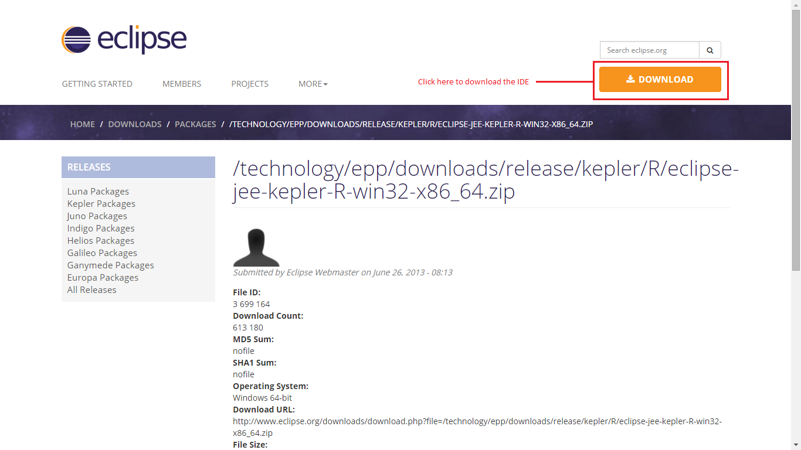

Extract the zip file and run the ‘*eclipse.exe’*.

Once the IDE got opened, create a sample project [Here in our case used the stand alone Certificate Mail Notification project].

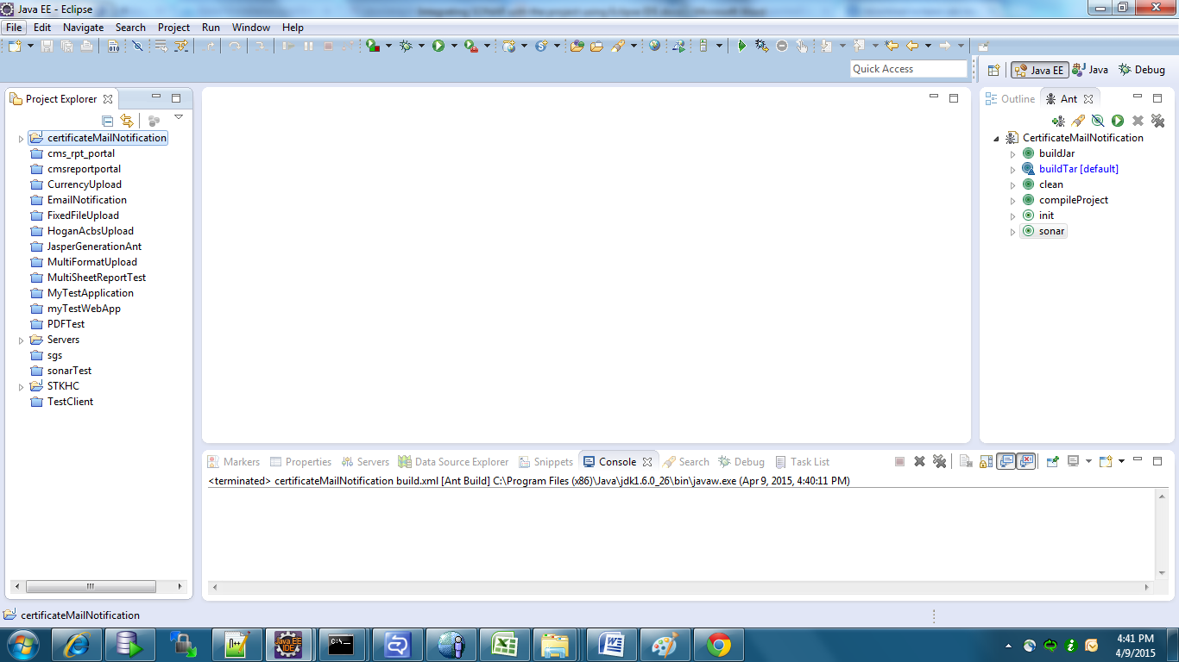

The following will document the SONAR cube set up for the above application. Ensure that the application is devoid of any compilation errors and the ANT run compilation executes successfully.

In IDE go to Main Menu 🡪 Help 🡪 Eclipse Marketspace as below

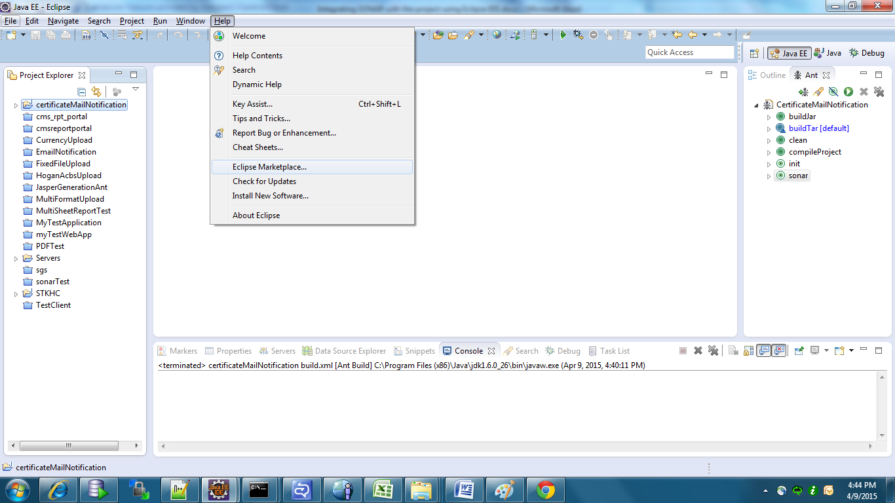

In the opened dialog, search for the string ‘***Sonar***’ and click ‘***Go***’

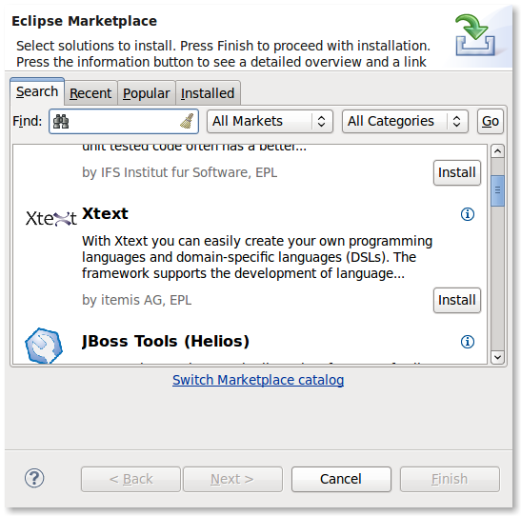

Click the ‘Install’ button against the plug-in named SonarQube [or simply Sonar in older version, which is not preferable]

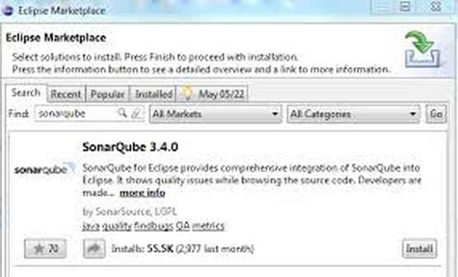

Choose the Sonar Java compatible plugin with other recommended plugins available in the opened window box.

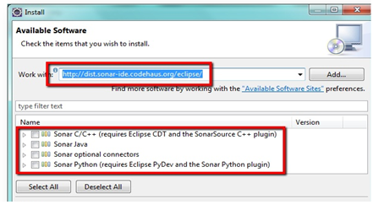

Click install. This will prompt a download of plug-ins and install the same in the IDE. Once completed restart the Eclipse IDE.

You can confirm the successful installation of the plug-in, by looking into window preferences, which now has option to configure Sonar related options [like server and so]

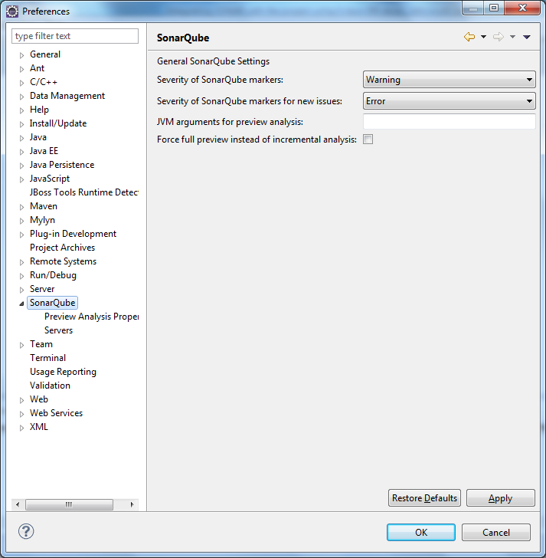

Sonar Qube runs over and generate the reports on the Sonar server. The sonar server can be downloaded using the below link

<http://www.sonarqube.org/downloads/>

In our case we used the version 3.7.4

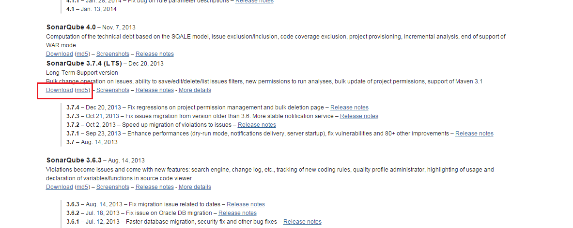

Extract the Sonar-3.7.4.zip file and go to ‘\sonar-3.7.4\bin\’.

Ensure that the configuration file has to be changed to accommodate the JAVA JDK for the SONAR server as below.

* Edit the ‘wrapper.conf’ file at ‘<root>\sonar-3.4.7\conf\’
* Edit the entry ‘wrapper.java.command’ pointing to the ‘java.exe’ in the jdk location [JDK 6 or higher is required]
* Sample entry : ‘*wrapper.java.command=<java_root>/jdk6/bin/java*’
* 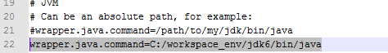

Based on the OS used, run the corresponding ‘StartSonar.sh / StartSonar.bat’ file. In our case we used the Windows 64bit one [for Win 7]

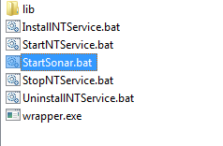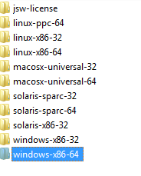

Execute ‘\sonar-3.7.4\bin\windows-x86-64\StartSonar.bat’ . The SonarQube start status will be tailed with the hostname as below.

This may take few minutes for the first run.

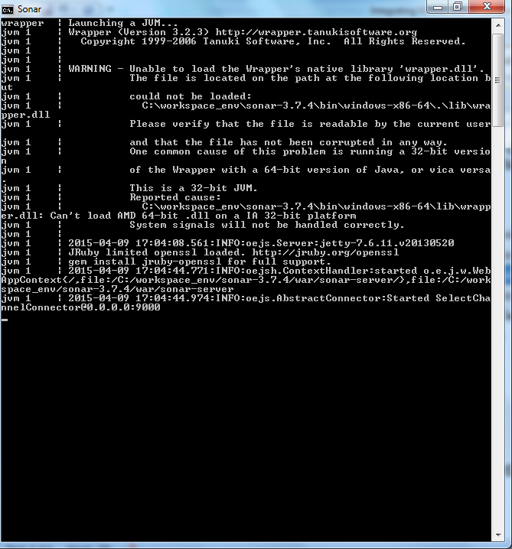

The SonarQube by default points to the localhost [or 0.0.0.0:9000, as in the screenshot above].

Open the eclipse Window 🡪 Preference 🡪 Servers 🡪 Select the ‘localhost’ server. Click on edit.

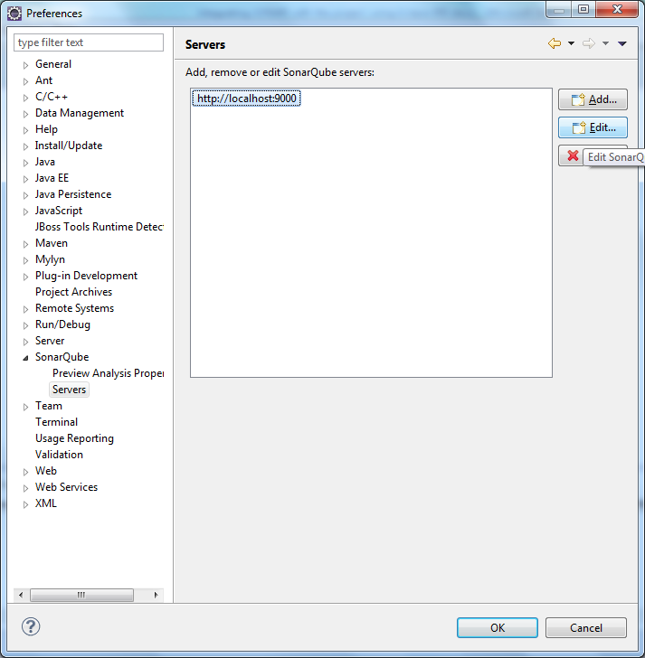

Click on ‘Test Connection’ to test whether the plugin in eclipse IDE is able to communicate with the SonarQube server successfully.

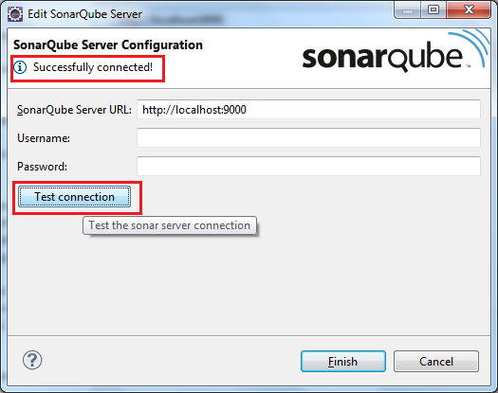

Add the following dependency into our applications ‘lib’ folder, along with other project dependency JARs.

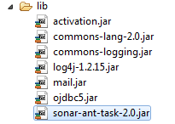

Also ensure the same is added in runtime. The JAR can be downloaded from the below location

<http://mvnrepository.com/artifact/org.codehaus.sonar-plugins/sonar-ant-task/2.0>

This will facilitate us to run the project under SonarQube via ANT target.

**Running SONAR QUBE via ANT:**

Open the ANT ‘build.xml’ and do the following changes.

1. Add the name space entry for ‘sonar’ in the root <project /> tag as below

*<project name="My Project Name" default="<the default target name>" basedir="."* ***xmlns:sonar="antlib:org.sonar.ant"****>*

1. Add the following ANT properties that are related to the SONAR

*<!-- Adding SONAR related variables -->*

*<property name="sonar.host.url" value="http://localhost:9000" />*

*<property name="sonar.projectKey" value="The name of the project" />*

*<property name="sonar.projectName" value="The name to be displayed in report" />*

*<property name="sonar.projectVersion" value="1.0" />*

*<property name="sonar.sources" value="The ‘src’ folder location" />*

*<property name="sonar.binaries" value="The output folder location” />*

*<property name="sonar.sourceEncoding" value="UTF-8" />*

*<!-- SONAR Qube server authentication details -->*

*<property name="sonar.login" value="admin" />*

*<property name="sonar.password" value="admin" />*

1. Add the below target in the XML with the compiling target as a dependency

*<target name="sonar" depends="<the compile ant target>">*

*<taskdef uri="antlib:org.sonar.ant" resource="org/sonar/ant/antlib.xml">*

*<classpath path="\${lib}\sonar-ant-task-2.0.jar" />*

*</taskdef>*

*<!-- Execute SonarQube -->*

*<sonar:sonar />*

*</target>*

1. Run the Sonar target from the ANT perspective

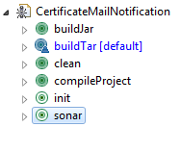

1. Running the same will execute the Sonar compatible run with the below console logs

*compileProject:*

*[javac] Compiling 10 source files to C:\Workspaces\workspace_exercise\certificateMailNotification\bin*

*sonar:*

*[sonar:sonar] Apache Ant(TM) version 1.8.4 compiled on May 22 2012*

*[sonar:sonar] Sonar Ant Task version: 2.0*

*[sonar:sonar] Loaded from: file:/C:/Workspaces/workspace_exercise/certificateMailNotification/lib/sonar-ant-task-2.0.jar*

*[sonar:sonar] Sonar work directory: C:\Workspaces\workspace_exercise\certificateMailNotification\.sonar*

*[sonar:sonar] Sonar server: http://localhost:9000*

*[sonar:sonar] 17:22:59.368 INFO - Load batch settings*

*[sonar:sonar] 17:22:59.602 INFO - User cache: C:\Users\1444058\.sonar\cache*

*[sonar:sonar] 17:22:59.602 INFO - Install plugins*

*[sonar:sonar] 17:23:00.148 INFO - Install JDBC driver*

*[sonar:sonar] 17:23:00.164 WARN - H2 database should be used for evaluation purpose only*

*[sonar:sonar] 17:23:00.164 INFO - Create JDBC datasource for jdbc:h2:tcp://localhost/sonar*

*[sonar:sonar] 17:23:00.930 INFO - Initializing Hibernate*

*[sonar:sonar] 17:23:03.974 INFO - Load project settings*

*[sonar:sonar] 17:23:04.037 INFO - Apply project exclusions*

*[sonar:sonar] 17:23:04.130 INFO - ------------- Scan CertificateMailNotification*

*[sonar:sonar] 17:23:04.146 INFO - Load module settings*

*[sonar:sonar] 17:23:04.551 INFO - Quality profile : [name=Sonar way,language=java]*

*[sonar:sonar] 17:23:04.567 INFO - Excluded tests:*

*[sonar:sonar] 17:23:04.567 INFO - **/package-info.java*

*[sonar:sonar] 17:23:04.598 INFO - Configure Maven plugins*

*[sonar:sonar] 17:23:04.645 INFO - Compare to previous analysis (2015-04-09)*

*[sonar:sonar] 17:23:04.661 INFO - Compare over 30 days (2015-03-10, analysis of 2015-04-09 16:24:49.975)*

*[sonar:sonar] 17:23:04.676 INFO - Compare to previous version*

*[sonar:sonar] 17:23:04.739 INFO - Initializer JacocoAntInitializer...*

*[sonar:sonar] 17:23:04.770 INFO - JaCoCo agent (version 0.6.2.201302030002) extracted: C:\Users\1444058\AppData\Local\Temp\jacocoagent7201894408484060802.jar*

*[sonar:sonar] 17:23:04.770 INFO - Initializer JacocoAntInitializer done: 31 ms*

*[sonar:sonar] 17:23:04.770 INFO - Base dir: C:\Workspaces\workspace_exercise\certificateMailNotification*

*[sonar:sonar] 17:23:04.770 INFO - Working dir: C:\Workspaces\workspace_exercise\certificateMailNotification\.sonar*

*[sonar:sonar] 17:23:04.770 INFO - Source dirs: C:\Workspaces\workspace_exercise\certificateMailNotification\src*

*[sonar:sonar] 17:23:04.770 INFO - Binary dirs: C:\Workspaces\workspace_exercise\certificateMailNotification\bin*

*[sonar:sonar] 17:23:04.770 INFO - Source encoding: UTF-8, default locale: en_US*

*[sonar:sonar] 17:23:04.817 INFO - Sensor JavaSourceImporter...*

*[sonar:sonar] 17:23:05.004 INFO - Sensor JavaSourceImporter done: 187 ms*

*[sonar:sonar] 17:23:05.004 INFO - Sensor JavaSquidSensor...*

*[sonar:sonar] 17:23:05.097 INFO - Java AST scan...*

*[sonar:sonar] 17:23:05.443 INFO - Java AST scan done: 346 ms*

*[sonar:sonar] 17:23:05.458 INFO - Java bytecode scan...*

*[sonar:sonar] 17:23:05.755 INFO - Java bytecode scan done: 297 ms*

*[sonar:sonar] 17:23:05.755 INFO - Package design analysis...*

*[sonar:sonar] 17:23:05.817 INFO - Package design analysis done: 62 ms*

*[sonar:sonar] 17:23:05.879 INFO - Sensor JavaSquidSensor done: 875 ms*

*[sonar:sonar] 17:23:05.879 INFO - Sensor SurefireSensor...*

*[sonar:sonar] 17:23:05.879 INFO - parsing C:\Workspaces\workspace_exercise\certificateMailNotification\.sonar\build\surefire-reports*

*[sonar:sonar] 17:23:05.879 INFO - Sensor SurefireSensor done: 0 ms*

*[sonar:sonar] 17:23:05.879 INFO - Sensor CpdSensor...*

*[sonar:sonar] 17:23:05.879 INFO - SonarEngine is used*

*[sonar:sonar] 17:23:05.895 INFO - Cross-project analysis disabled*

*[sonar:sonar] 17:23:06.035 INFO - Sensor CpdSensor done: 156 ms*

*[sonar:sonar] 17:23:06.035 INFO - Sensor CheckstyleSensor...*

*[sonar:sonar] 17:23:06.035 INFO - Execute Checkstyle 5.6...*

*[sonar:sonar] 17:23:06.051 INFO - Checkstyle configuration: C:\Workspaces\workspace_exercise\certificateMailNotification\.sonar\checkstyle.xml*

*[sonar:sonar] 17:23:06.410 INFO - Execute Checkstyle 5.6 done: 375 ms*

*[sonar:sonar] 17:23:06.410 INFO - Sensor CheckstyleSensor done: 375 ms*

*[sonar:sonar] 17:23:06.410 INFO - Sensor PmdSensor...*

*[sonar:sonar] 17:23:06.410 INFO - Execute PMD 4.3...*

*[sonar:sonar] 17:23:06.425 INFO - Java version: 1.5*

*[sonar:sonar] 17:23:06.472 INFO - PMD configuration: C:\Workspaces\workspace_exercise\certificateMailNotification\.sonar\pmd.xml*

*[sonar:sonar] 17:23:07.113 INFO - Execute PMD 4.3 done: 703 ms*

*[sonar:sonar] 17:23:07.144 INFO - Sensor PmdSensor done: 734 ms*

*[sonar:sonar] 17:23:07.144 INFO - Sensor InitialOpenIssuesSensor...*

*[sonar:sonar] 17:23:07.191 INFO - Sensor InitialOpenIssuesSensor done: 47 ms*

*[sonar:sonar] 17:23:07.191 INFO - Sensor ProfileSensor...*

*[sonar:sonar] 17:23:07.659 INFO - Sensor ProfileSensor done: 468 ms*

*[sonar:sonar] 17:23:07.659 INFO - Sensor ProfileEventsSensor...*

*[sonar:sonar] 17:23:07.674 INFO - Sensor ProfileEventsSensor done: 15 ms*

*[sonar:sonar] 17:23:07.674 INFO - Sensor ProjectLinksSensor...*

*[sonar:sonar] 17:23:07.674 INFO - Sensor ProjectLinksSensor done: 0 ms*

*[sonar:sonar] 17:23:07.674 INFO - Sensor VersionEventsSensor...*

*[sonar:sonar] 17:23:07.690 INFO - Sensor VersionEventsSensor done: 16 ms*

*[sonar:sonar] 17:23:07.690 INFO - Sensor JaCoCoSensor...*

*[sonar:sonar] 17:23:07.706 INFO - Project coverage is set to 0% as no JaCoCo execution data has been dumped: C:\Workspaces\workspace_exercise\certificateMailNotification\target\jacoco.exec*

*[sonar:sonar] 17:23:07.846 INFO - No information about coverage per test.*

*[sonar:sonar] 17:23:07.846 INFO - Sensor JaCoCoSensor done: 156 ms*

*[sonar:sonar] 17:23:08.002 INFO - Execute decorators...*

*[sonar:sonar] 17:23:09.034 INFO - Store results in database*

*[sonar:sonar] 17:23:09.205 INFO - ANALYSIS SUCCESSFUL, you can browse http://localhost:9000/dashboard/index/CertificateMailNotification*

*[sonar:sonar] 17:23:09.283 INFO - Executing post-job class org.sonar.plugins.core.issue.notification.SendIssueNotificationsPostJob*

*[sonar:sonar] 17:23:09.283 INFO - Executing post-job class org.sonar.plugins.core.batch.IndexProjectPostJob*

*[sonar:sonar] 17:23:09.439 INFO - Executing post-job class org.sonar.plugins.dbcleaner.ProjectPurgePostJob*

*[sonar:sonar] 17:23:09.455 INFO - -> Keep one snapshot per day between 2015-03-12 and 2015-04-08*

*[sonar:sonar] 17:23:09.455 INFO - -> Keep one snapshot per week between 2014-04-10 and 2015-03-12*

*[sonar:sonar] 17:23:09.455 INFO - -> Keep one snapshot per month between 2010-04-15 and 2014-04-10*

*[sonar:sonar] 17:23:09.455 INFO - -> Delete data prior to: 2010-04-15*

*[sonar:sonar] 17:23:09.455 INFO - -> Clean CertificateMailNotification [id=18]*

*[sonar:sonar] 17:23:09.470 INFO - <- Clean snapshot 103*

*BUILD SUCCESSFUL*

*Total time: 21 seconds*

1. Hit the browser with the URL <http://localhost:9000/>
2. If the above is not working hit with <http://0.0.0.0:9000> or bypass the localhost in the LAN Settings of the browser
3. The resultant will be a detailed Sonar Report as in the below screenshots

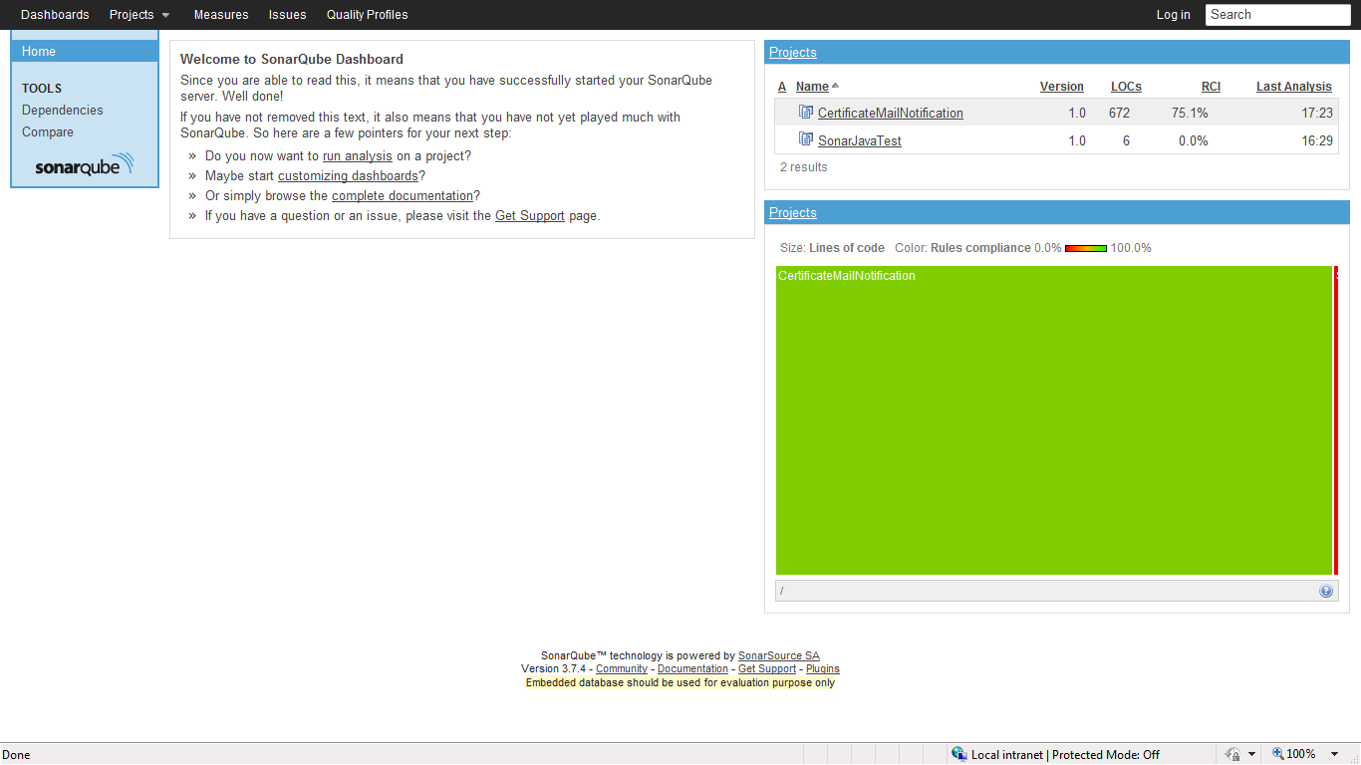 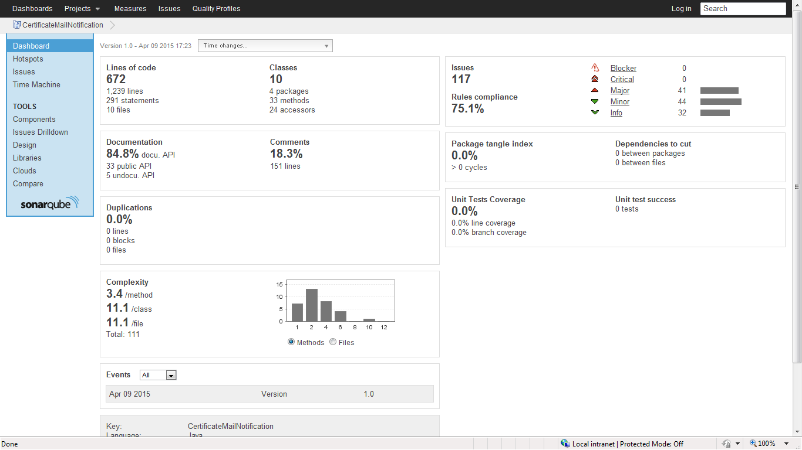 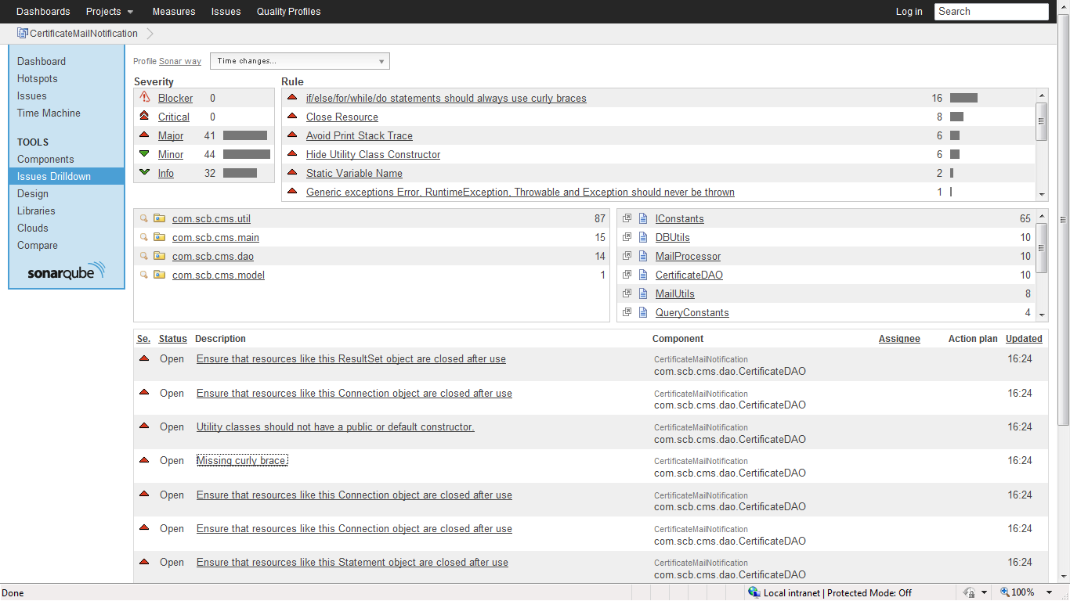 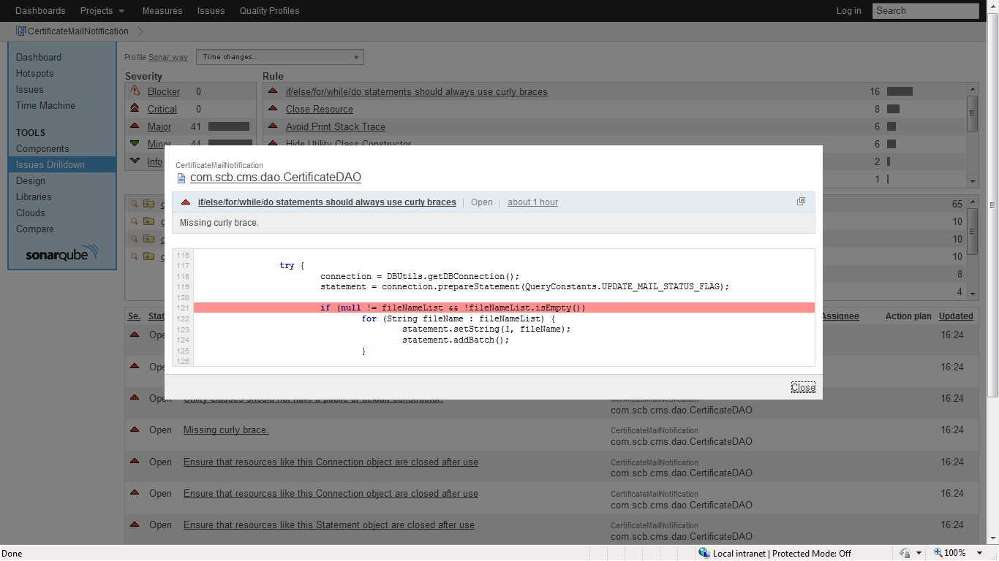

**Modifying Rule set in SONAR server**

Every sonar server generates reports with an underlying rule-set. Changing the default or uploading the rule sets are to be carried out as server admin.

Open the SONAR server dashboard and click on login [at the top right].

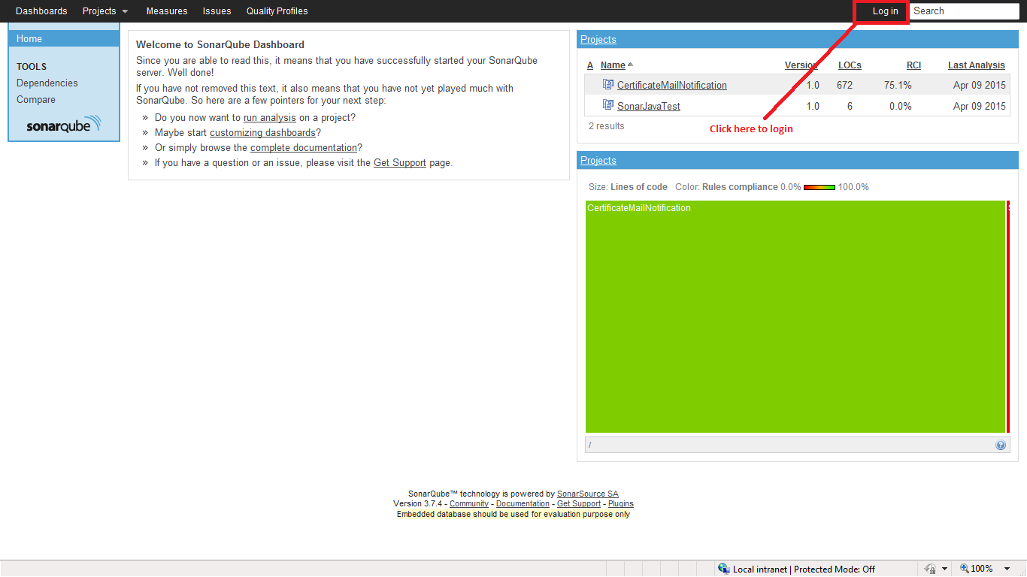

To login as administrator, login with username ‘**admin**’ and the password as ‘**admin**’ [default password]

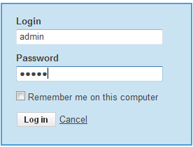

Click on the ‘**Quality Profiles**’ from the Menu. This will list down all the rule sets that are used and the default rule-set that has been used to generate the current sonar report.

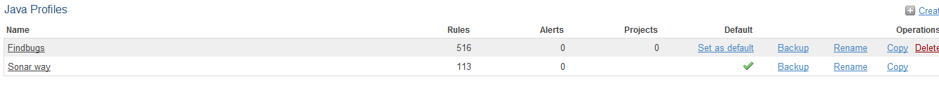

Click on the create link, specify a new rule set name and upload the new Rule-set [XML or CSV].

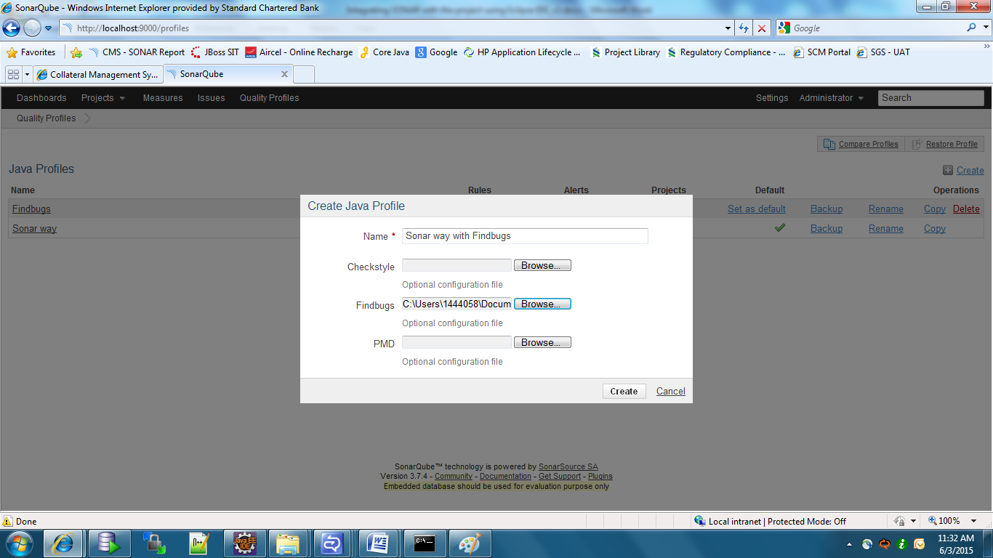

Click on create to complete the upload of the new Rule-set creation.

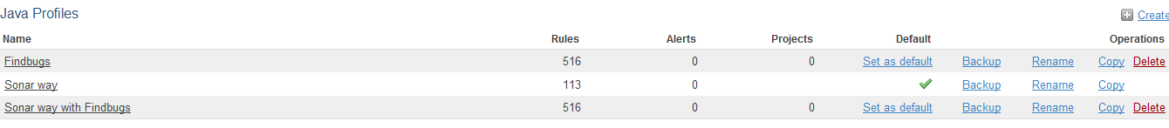

Now, so as to mark the newly added rule-set as the default one, click on the set as default link.

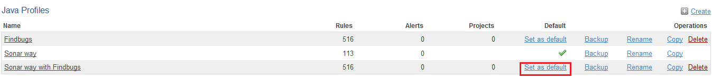

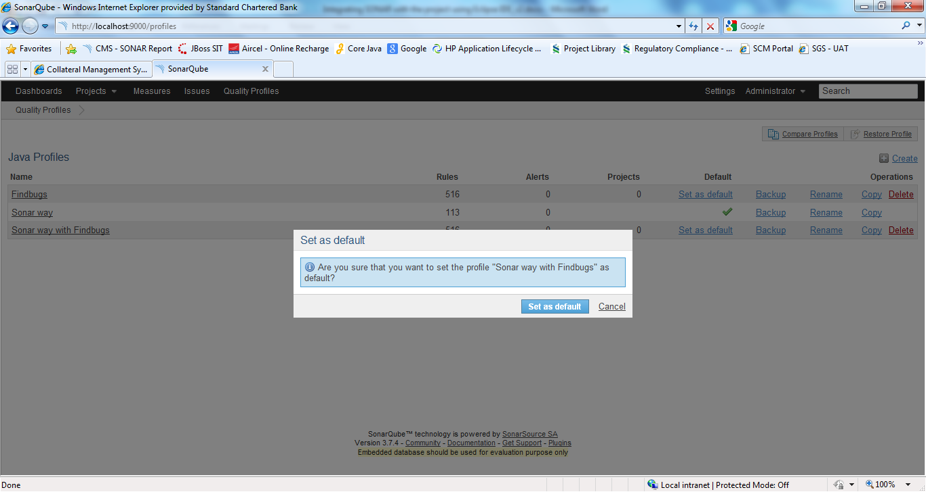

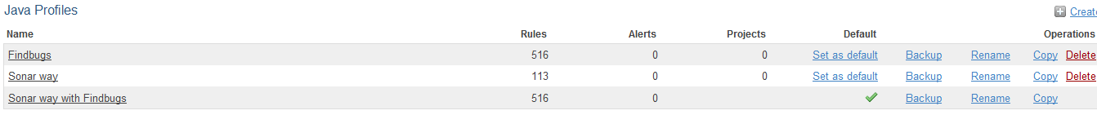

Now the SonarQube server points to this particular rule-set to generate its reports.

The same screen will allow us to compare the different rulesets.

Admin settings like ‘Changing Password’, ‘Creating a new User’ and all the other related activities can be carried out from the setting menu as below

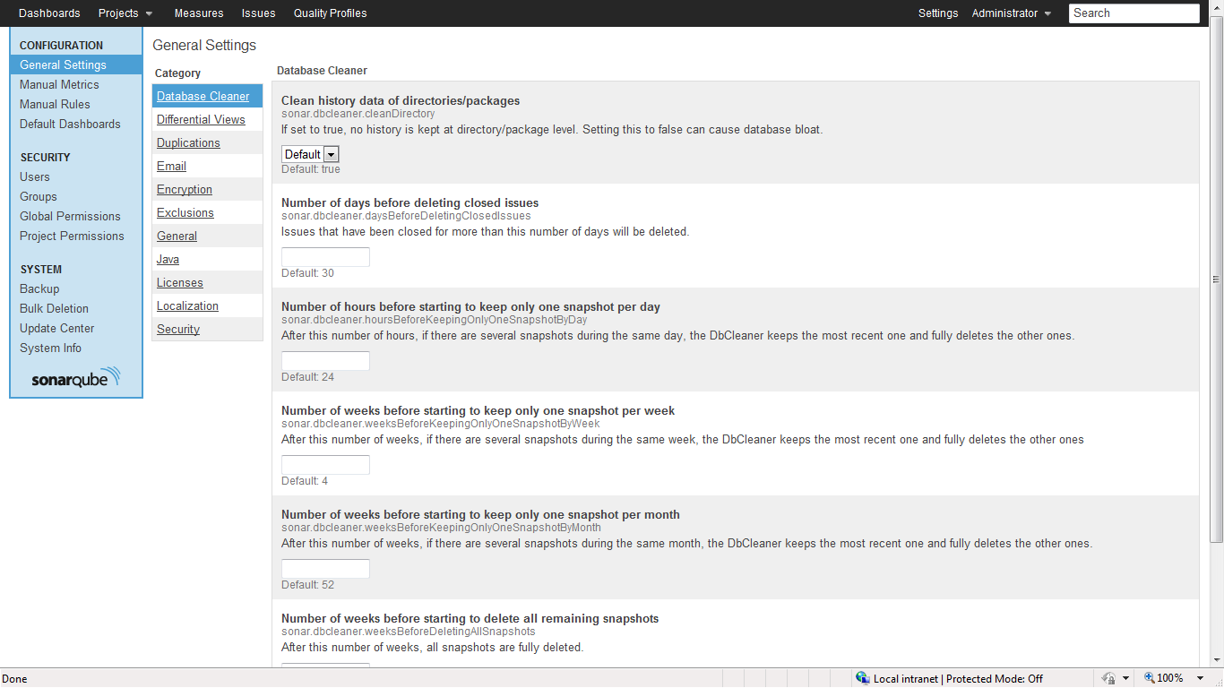

The find bug rule set used is as follow

 